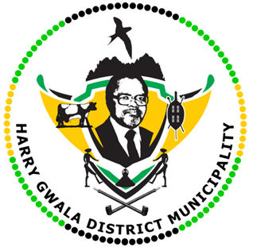
HARRY GWALA DISTRICT MUNICIPALITY
“Together We Deliver and Grow”
OFFICE OF THE MUNICIPAL MANAGER
40 Main Street, Private Bag X501, IXOPO 3276
Tel: (039) 834 8707 Fax: (039) 834 1701
Email: NgubaneN1@harrygwaladm.gov.za

27 APRIL 2023

Freedom Day Message by His Worship the Mayor of the Harry Gwala District Municipality, Cllr ZD Nxumalo
The 27 of April 2023 marks exactly 29 years since the birth of our beloved country as the date is the anniversary of the first democratic elections held in South Africa. This day is important for all of us to observe as it is the day for us to commemorate and honour our heroes and heroines who fought for the liberation of our country which heralded many firsts for the majority of the people of this country. These included, but are not limited to, equality in many fronts, such as equality before the law, opportunities, and representation.
As we reflect on the journey our country has traversed since 27 April 1994, I cannot but fully agree with the painful conclusion that our minds, bodies and souls still replicate the traumas and scars which remind us constantly that our liberation came at huge price and indeed for the tens of thousands of our heroes and heroines who were jailed, tortured and killed, the freedom we enjoy today is a testament to this.
On April 27 1995 , during the first anniversary of the democratic elections, our former President, Nelson Mandela said: “as dawn ushered in this day, few of us could suppress the welling of emotion as we were reminded of the terrible past from which we come as a nation; the great possibilities that we now have…The birth of our South African nation has, like any other, passed through a long and often painful process…The national day also honours the masses of South Africans who resisted and suffered under apartheid, and faced death, injury and repression from the security forces. Many others battled forced removals, discrimination, and other injustices…”
With the celebrations of the 29-year anniversary milestone, our citizens should reflect on the gains made and opportunities created while examining the insurmountable possibilities that exist in wait for our nation.
Happy Freedom Day to ALL
ISSUED BY HARRY GWALA DISTRICT MUNICIPALITY COMMUNICATIONS UNIT.
0398348700

